**DATA FLOW DIAGRAM**

|  |  |
| --- | --- |
| Project Title | News Tracker Application |
| Team ID | PNT2022TMID05721 |
| Team Members | Shivani . N  Akarshan . S  Surya Narayanan. R.U  Venkat Sowmya .R |

**DATAFLOW DIAGRAM**

Data Flow Diagram (DFD) is a traditional visual representation of the information flows within a system. A neat and clear DFD can depict the right amount of the system requirement graphically. It shows how data enters and leaves the system, what changes the information, and where data is  stored.

**SIMPLIFIED**

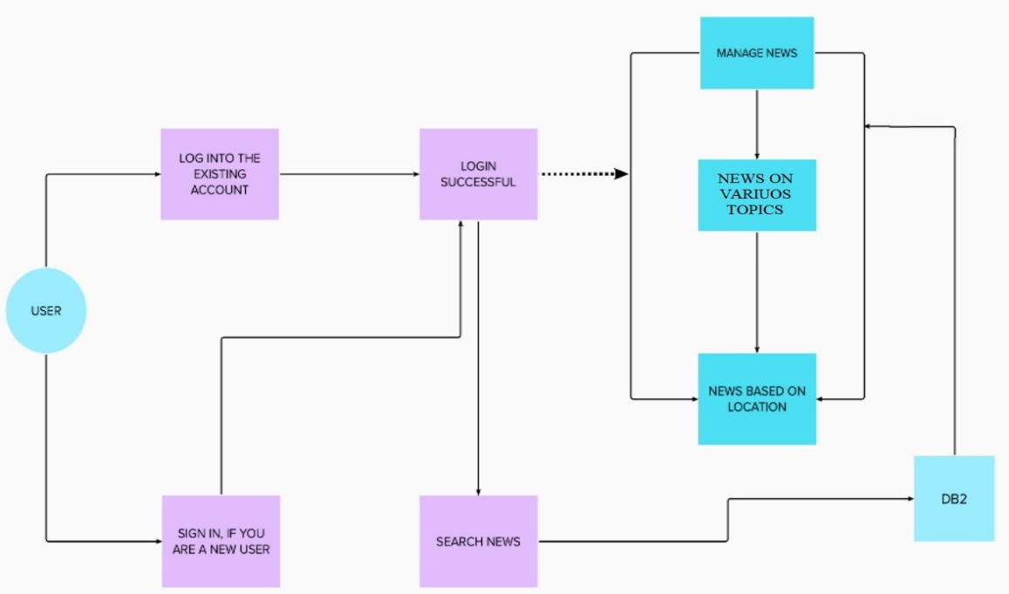

**INDUSTRY STANDARD**

